Guía2. Desarrollo Proyecto APT
Asignatura Capstone

Personal Background
Below is a table in which you must complete the requested information.

Student Name | Ruth | Career | Headquarters
Lucas Joaquin Carvajal Pincheira | 21.146.055-5 | Computer Engineering | Viña del Mar
Osvaldo Antonio Reyes Wiegand | 19.336.327-k | Computer Engineering | Viña del Mar

1. Summary of APT Project Progress
Below, you will find different fields that you must complete with the requested information.

APT project progress summary | During this phase, progress has focused primarily on consolidating the data infrastructure and analytical baseline of the Predictive Demand and Inventory Optimization System for the wholesale clothing and footwear distributor in the Valparaíso region (Quilpué/Viña del Mar). An automated extraction, transformation, and cleaning (ETL) pipeline was successfully implemented in Python with Pandas, filtering null values and correcting inconsistencies. Additionally, a containerized Microsoft SQL Server 2022 relational database engine was deployed using Docker Compose on port 1434 with volume persistence, to which the cleaned data was fully loaded using SQLAlchemy. Finally, the initial predictive Machine Learning model (Random Forest Regressor) was trained, achieving a baseline Mean Absolute Error (MAE) of 24.11 units, and the development of the executive web dashboard in Streamlit began for the client to view early inventory alerts.
Goals | - Develop a predictive software system based on Machine Learning to optimize inventory management and estimate future product demand in a textile and footwear marketing company.  - Implement an automated data ingestion, debugging, and normalization (ETL) pipeline in Python to ensure the integrity of sales records.  - Deploy and configure the relational/dimensional database in Microsoft SQL Server 2022 using Docker containers to ensure the persistence and centralization of transactional information.  - Train and evaluate Machine Learning models (Random Forest / Time Series) using formal quantitative metrics (MAE/MAPE) to project seasonal purchase volume.  - Build an interactive web interface in Streamlit that allows the marketing company's user to view sales reports, demand forecasts, and preventive stockout alerts.
Methodology | The project continued to develop under the Scrum agile framework, adapted to the academic context through iterative and incremental deliveries focused on data architecture and applied artificial intelligence. The agile ceremonies and guidelines defined by the team were maintained.  - Sprint Planning and Daily Meetings: Planning sessions were held at the beginning of the cycles and remote synchronization meetings (2 to 3 times per week) to coordinate workloads between technical roles (Osvaldo Reyes in database architecture, ETL and Machine Learning algorithms; Lucas Carvajal in requirements engineering, document quality assurance, test design and KPI calculation).  - Sprint Review and Retrospective: At the end of each cycle, the functional technical increments (ETL scripts, Docker orchestration, SQL Server migration scripts, and AI training console) were reviewed, analyzing enablers and hindrances (such as the lack of clean historical customer data and credential management) and agreeing on versioning and security improvements.  - The technical work was supported by Visual Studio Code, Python (Pandas, Scikit-Learn, SQLAlchemy, PyODBC), Microsoft SQL Server 2022 containerized on Docker Desktop, and Streamlit for the presentation layer. Unit tests, integration tests, and quantitative metrics were applied to support software quality.
Evidence of progress | The evidence presented corresponds to the deliverables committed to in formal document 1.5 of Phase 1 and the software quality assurance guideline:  - ETL Pipeline and Persistence Model (Milestone 2 / Progress 1): Python script cleans the customer database and transfers it to the file ventas_limpio_sql.csv (950 records with 100% integrity), and bulk migration script ( cargar_bd.py ) connected to SQL Server.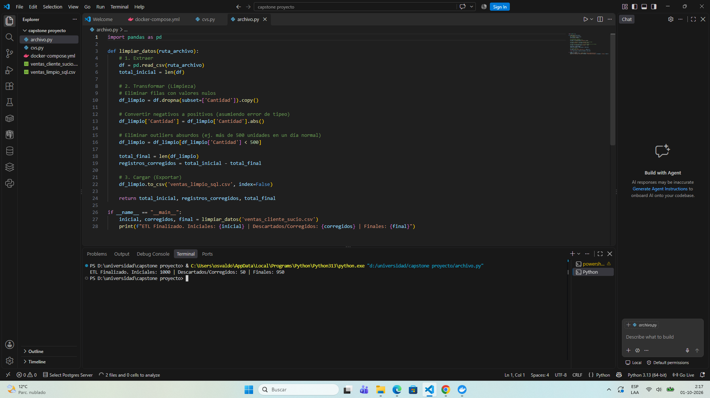  - Containerized Infrastructure: docker-compose.yml orchestration file running the sqlserver-docker service ( mssql/server:2022-latest image , bd_capstone_sql container on port 1434 with persistent volume sqlserver_data ).  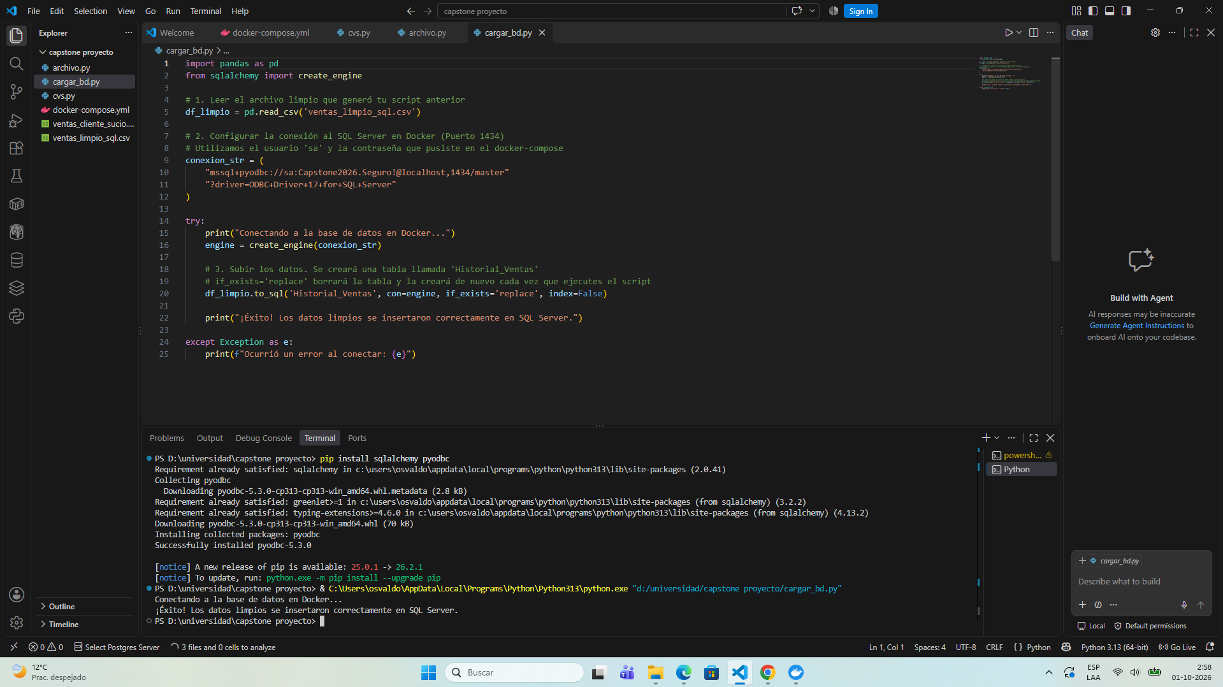  - Artificial Intelligence Predictive Engine (Milestone 3): Machine Learning training source code (Random Forest) executed with 80/20 train/test partition, yielding a Mean Absolute Error (MAE) measured on console of 24.11 units per garment, supported as a basis for seasonal inference.  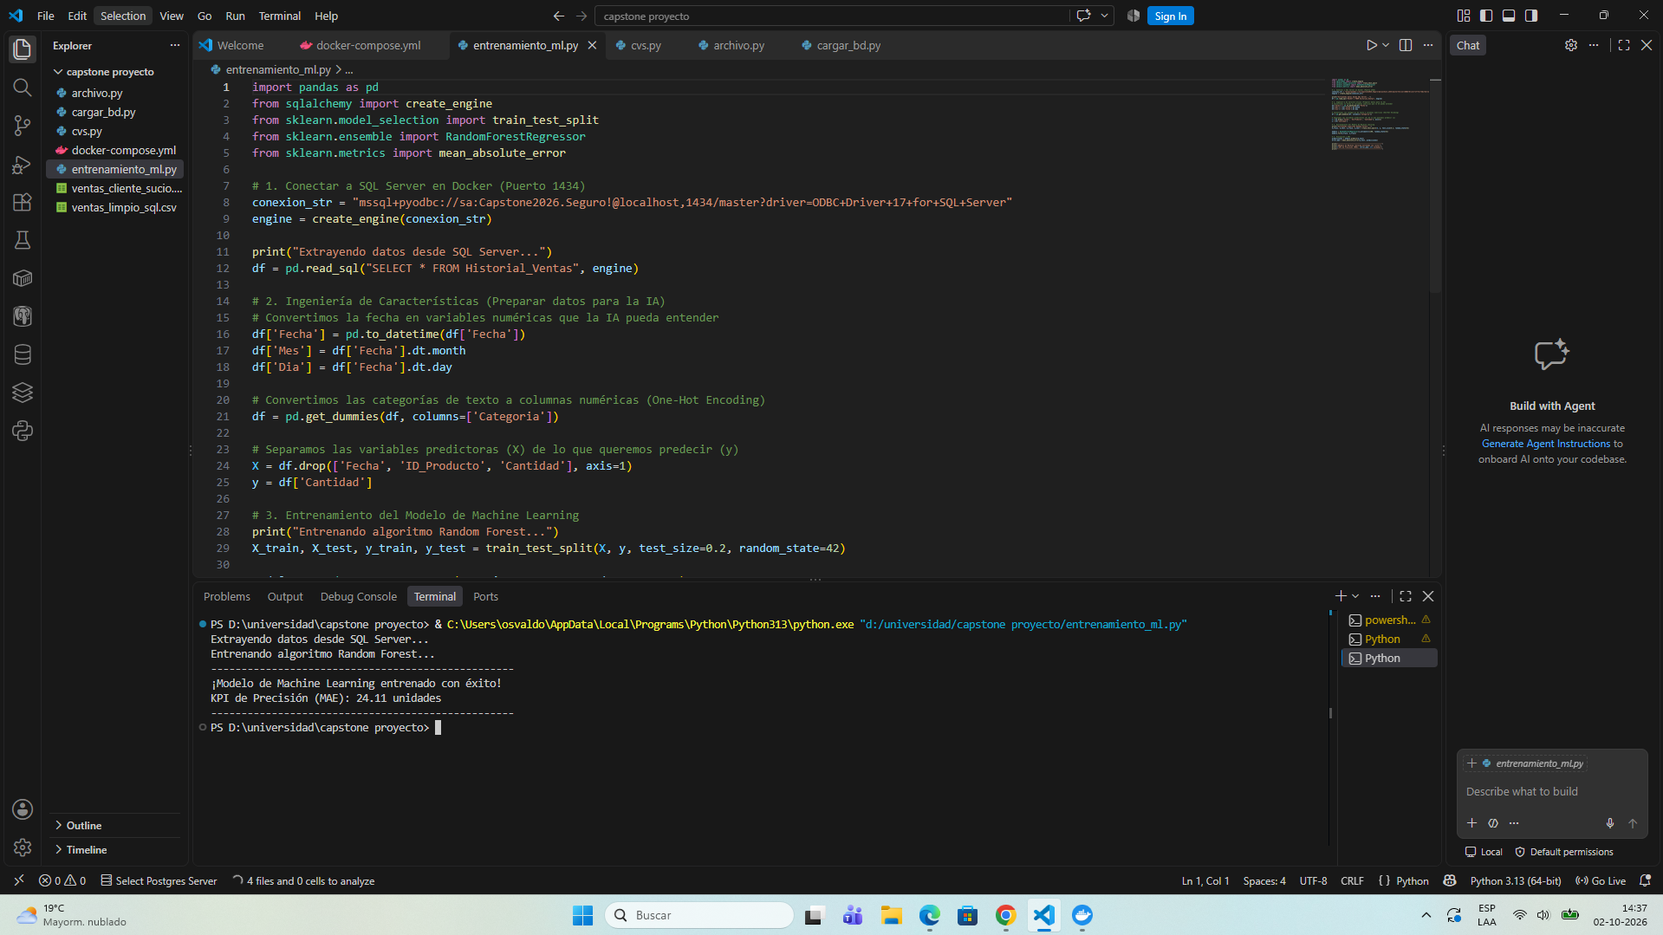  - Unit and Integration Test Cases: Formal execution of tests PU-01 ( dropna ), PU-02 ( abs ), PI-01 (ETL + CSV) and PI-02 (Python + Docker SQL Server) with Passed status  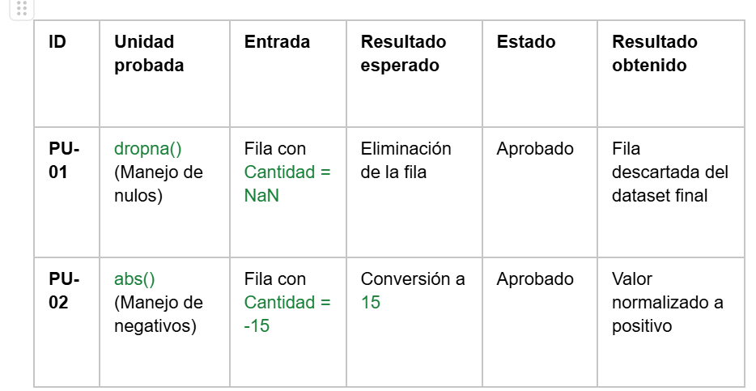.  - Technical Metrics and KPIs: Formal record of KPI-01 (Intake Quality: 100% of data processed without anomalous values) and KPI-02 (Predictive Model Accuracy: Initial MAE of 24.11 units).  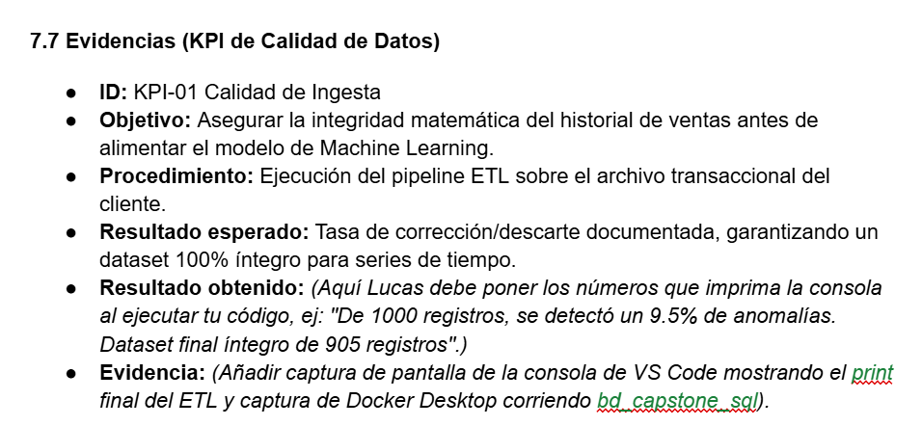

2. Monitoring of the Work Plan
Carefully examine your work plan, focusing especially on the status column for progress and adjustments.

APT Project Work Plan
Competence or units of competence | Activities | Resources | Duration of the activity | Responsible | Observations | Progress status | Settings
Requirements Engineering | Phase 1: Gathering requirements and defining inventory variables | Virtual/in-person meeting with client, Text documents | 1 week | Lucas Carvajal | Clarity in the wholesale purchasing problem; the obstacle was the lack of formal structuring in the customer history | Filled | No adjustments have been made
Agile Management (Scrum) | Phase 1: Definition of roles, Product Vision and prioritized Backlog | Scrum templates, Visual Studio Code | 1 week | Lucas Carvajal and Osvaldo Reyes | It facilitated an equitable division between data engineering/AI and document assurance; the obstacle was coordinating delivery times | Filled | No adjustments have been made
Data architecture and management | Phase 1: Definition of architecture, persistence strategy and Docker | Docker Desktop, docker-compose.yml | 2 weeks | Osvaldo Reyes | Containerization ensured immediate portability; the obstacle was the local port 1433 conflict | Filled | No adjustments have been made
Data Engineering (ETL) | Phase 2 - Sprint 1: Synthetic generation and data cleaning pipeline | Python, Pandas, Visual Studio Code | 2 weeks | Osvaldo Reyes | The use of Pandas allowed for vectorizing the cleanup; the obstacle was designing plausible anomalies in 4 categories | Filled | Generation of a synthetic dataset of 1,000 rows
Relational databases | Phase 2 - Sprint 1: Mass migration and push to Docker | SQLAlchemy, PyODBC, Docker Container | 1 week | Osvaldo Reyes | Robust connection without record loss; the obstacle was the compatibility of the ODBC driver in the operating system | Filled | No adjustments have been made
Artificial intelligence | Phase 2 - Sprint 2: Training of the baseline predictive model and calculation of MAE | Python, Scikit-Learn (Random Forest), VS Code | 2 weeks | Osvaldo Reyes | Tree assembly computation speed; the obstacle was balancing the 80/20 validation split | Filled | No adjustments have been made
QA / Testing and Quality | Phase 2: Unit testing, integration, and formalization of KPIs | Testing Scripts, VS Code Terminal | 2 weeks | Lucas Carvajal | Tests PU-01 to PI-02 passed; the obstacle was capturing the exact times and metrics on the console | Filled | The KPI-01 and KPI-02 data sheets were formalized.
Frontend / UI Development | Phase 2 - Sprint 3: Dashboard layout and alerts module | Streamlit, Python, Visual Studio Code | 2 weeks | Osvaldo Reyes and Lucas Carvajal | Streamlit enables agile development in Python; the challenge is connecting the suggestion logic with the graphics. | In progress | Visual components under development
Software security | Phase 2: Environment variable management and network isolation | File .env , .env.example , .gitignore | 1 week | Lucas Carvajal | Isolate credentials from the repository; the obstacle was removing plaintext passwords from legacy scripts | In progress | Passwords are decoupled from the .env file
Technical documentation | Phase 2: Consolidation of Phase 2 report, technical manual and README | Word, Markdown, Architecture Diagrams | 1 week | Lucas Carvajal | Full evidence support; the obstacle is the time required to diagram the comprehensive architecture | In progress | No adjustments have been made

3. Adjustments based on monitoring
Delve deeper into the observations of your work plan. Analyze the planned activities and identify which aspects facilitated or hindered the plan's execution. Explain how you addressed and/or will address the obstacles. Finally, indicate the adjustments you made to the work plan based on this analysis.

Factors that have facilitated and/or hindered the development of my work plan :
Facilitating factors: The strict division of roles and disciplinary responsibilities among team members (Osvaldo Reyes in technical architecture, script development, and algorithmic modeling, and Lucas Carvajal in requirements management, test case design, and document assurance) was crucial. Furthermore, the use of modern tools like Docker Desktop enabled the rapid deployment of a standardized and reproducible SQL Server 2022 database engine, reducing local software configuration time.
Obstacles: The migration and integration of Microsoft SQL Server using Docker Desktop presented an initial technical challenge to the project's data architecture. Initially, the transition was hampered by network conflicts with the default port (1433) and compatibility issues with the local ODBC drivers. However, this obstacle was overcome by reconfiguring the Docker Compose orchestration to use the external port 1434 and adjusting the connection strings using SQLAlchemy and PyODBC in Python, which ultimately ensured data persistence, isolation, and portability.

Activities adjusted or eliminated:
Database port reconfiguration: The network configuration in the docker-compose.yml file was adjusted to bind the service through port 1434:1433 , adapting the connection string of the Python scripts to localhost,1434 without altering the integrity of the container.
No activities were eliminated: All tasks associated with software engineering, data architecture, development of Machine Learning models and development of the user interface remain within the scope.

Activities you haven't started or are behind schedule: According to the schedule set in document 1.5 of the phase 1 delivery, we are making progress in terms of the joint work of phase 2, the activities in process are minimal, the system is functional and requires minor details, the data collection will be carried out beforehand and the documentation is in process, currently being carried out.

Critical infrastructure activities, ETL cleanup pipelines, loading into SQL Server, Machine Learning training, and unit/integration testing are now fully completed.
The tasks currently in progress are the layout and linking of the web interface in Streamlit ( app.py ) for the deployment of inventory alerts and the writing of the technical manual and consolidation of the official report.
The activity that has not yet started corresponds to Phase 3: Final stress tests with the user, operational validation in the field and the formal defense of the Title Portfolio subject before the evaluation committee

